CREATE TABLE account(

user_id serial PRIMARY KEY,

username VARCHAR(50) UNIQUE NOT NULL,

password VARCHAR(50) NOT NULL,

email VARCHAR(355) UNIQUE NOT NULL,

created_on TIMESTAMP NOT NULL,

last_login TIMESTAMP);

CREATE TABLE role(

role_id serial PRIMARY KEY,

role_name VARCHAR(255) UNIQUE NOT NULL

);

CREATE TABLE account_role(

user_id integer NOT NULL,

role_id integer NOT NULL,

grant_date timestamp without time zone,

PRIMARY KEY(user_id, role_id),

CONSTRAINT account_role_role_id_fkey FOREIGN KEY (role_id)

REFERENCES role (role_id) MATCH SIMPLE

ON UPDATE NO ACTION ON DELETE NO ACTION,

CONSTRAINT account_role_user_id_fkey FOREIGN KEY (user_id)

REFERENCES account (user_id) MATCH SIMPLE

ON UPDATE NO ACTION ON DELETE NO ACTION

);

Challenge:

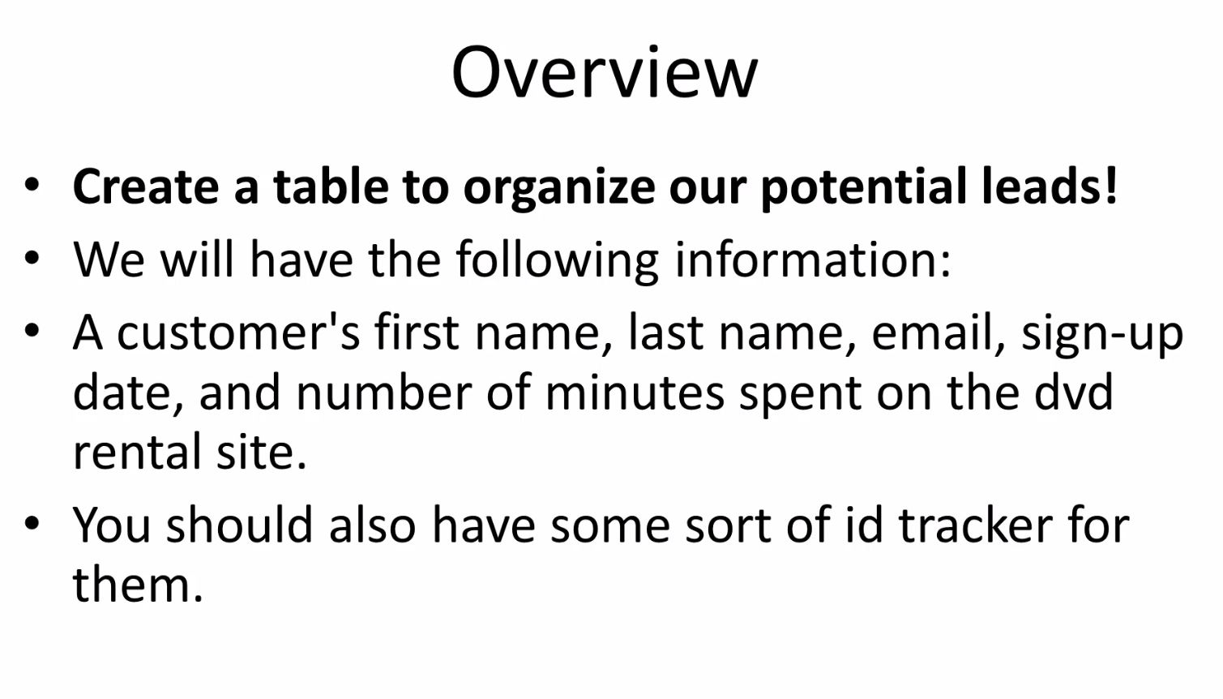

CREATE TABLE customer (

customer_id serial PRIMARY KEY,

first_name VARCHAR(50) NOT NULL,

last_name VARCHAR(50) NOT NULL,

email VARCHAR(355) UNIQUE NOT NULL,

sign_up_date TIMESTAMP NOT NULL,

number_of_minutes_spent integer NOT NULL

);